
Name | Rifaya Banu Magdoom
Contact Number | 07947852274
Project Title (Example – Week1, Week2, Week3) | Project - Week 3: ML Approach for Forecasting and Decision making in Sales Data

PROJECT - WEEK 3: ML APPROACH FOR FORECASTING AND DECISION MAKING IN SALES DATA

Objective: To apply advanced data analysis techniques to derive actionable business insights. This includes predictive analytics, statistical modeling, and machine learning approaches for forecasting and decision-making.
Tools Used: Microsoft Excel, Python(Google Colab)

DATA CLEANING
With the first examination of the data, we could find that there are no missing data or duplicates in the data. There are 4 numerical columns - Total_Spend, Purchase_Frequency, Marketing_Spend, Seasonality_Index; 1 logical data column - Churned.

- To load the data to Google Colab:

from google.colab import drive
drive.mount('/content/drive')
file_path = '/content/drive/My Drive/Data Analyst Projects/Week 3/raw_sales_data.xlsx'
df = pd.read_excel(file_path)
df

- To find if any cell is empty or null:
miss_val = df.isnull().sum()
miss_val
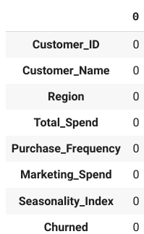 This result concludes with the initial findings that there are no null values in the dataset.
- To find the outliers:

from scipy import stats
num_cols = ["Total_Spend", "Purchase_Frequency", "Marketing_Spend"]
z_scores = np.abs(stats.zscore(df[num_cols]))
print(z_scores)
outlier_rows = (z_scores > 3).any(axis=1)
outliers_zscore = df[outlier_rows]
print("Outliers detected using Z-Score Method:")
print(outliers_zscore)

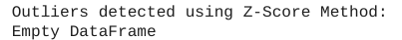

There are no outliers in the dataset.
Below is the boxplot for the numerical columns, which concludes that there are no outliers.

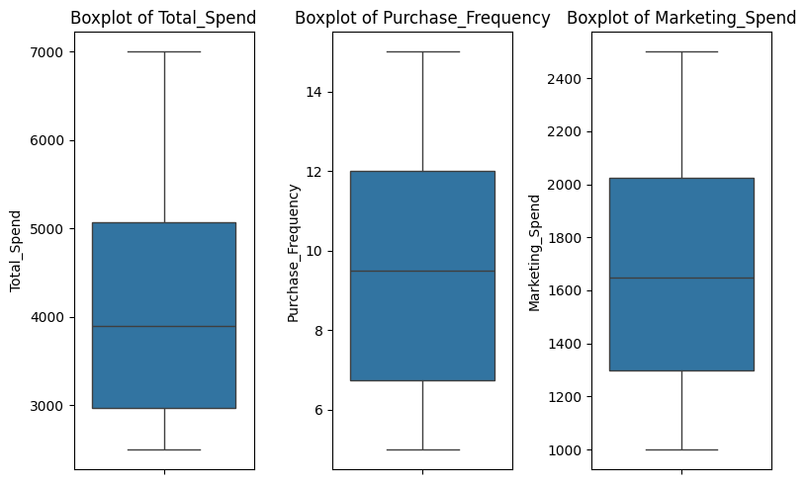

- Finding and removing inconsistent categorical variables:

Applied for the categorical data columns - Region and Churned

from sklearn.preprocessing import LabelEncoder
region_category = pd.DataFrame({'Region':['North','South','East','West']})
churned_category = pd.DataFrame({'Churned':['Yes','No']})
correct_region_category = set(df['Region'].unique())
correct_churned_category = set(df['Churned'].unique())
wrong_region_category = correct_region_category.difference(region_category['Region'])
print(wrong_region_category)
wrong_churned_category = correct_churned_category.difference(churned_category['Churned'])
print(wrong_churned_category)
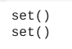
The result concludes that there are no inconsistent categorical variables in the dataset.

PREDICTIVE MODELING FOR SALES FORECASTING

- Apply Linear Regression to predict sales based on marketing spend and seasonality.
from sklearn.linear_model import LinearRegression
from sklearn.model_selection import train_test_split
from sklearn.metrics import mean_absolute_error, mean_squared_error, r2_score
X = df[['Marketing_Spend','Seasonality_Index']]
y = df['Total_Spend']
X_train, X_test, y_train, y_test = train_test_split(X, y, test_size=0.2, random_state=42)
model = LinearRegression()
model.fit(X_train, y_train)
y_pred = model.predict(X_test)
sample = pd.DataFrame({'Actual':y_test,'Predicted':y_pred})
print(sample)
print("Intercept:", model.intercept_)
print("Coefficients:", model.coef_)
# Feature Importance
coefficients = pd.DataFrame({'Feature': X.columns, 'Coefficient': model.coef_})
print(coefficients)
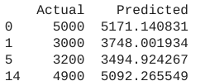

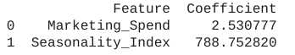

- The Coefficient value for Marketing spend is 2.5308, which indicates that every £1 increase in Marketing spend will increase the sales by £2.5308. This shows the positive impact on how the money spent on marketing drives more sales.
- Also, for every 1 unit of increase in Seasonality index, the total sales might increase £788.75; which represents the seasonal demand and thus the sales.

plt.scatter(y_test, y_pred, color='blue')
for actual, predicted in zip(y_test, y_pred):
plt.text(actual, predicted, f'{predicted:.0f}', fontsize=9, ha='right', va='bottom')
plt.plot([min(y_test), max(y_test)], [min(y_test), max(y_test)], color='red', linestyle='-')
plt.xlabel("Actual Sales (Total Spend)")
plt.ylabel("Predicted Sales (Total Spend)")
plt.title("Actual vs Predicted Sales")
plt.show()

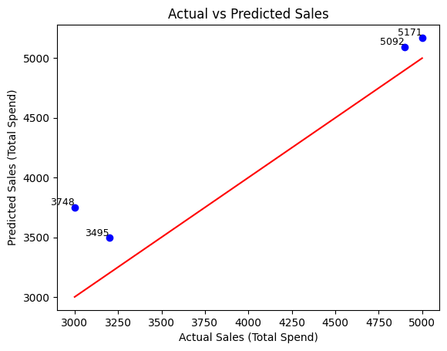

- Implement Logistic Regression to classify whether a customer will churn based on historical data

from sklearn.preprocessing import LabelEncoder, StandardScaler
from sklearn.linear_model import LogisticRegression
from sklearn.metrics import accuracy_score, confusion_matrix, classification_report
df['Churned'] = df['Churned'].map({'Yes': 1, 'No': 0})
X = df[['Marketing_Spend', 'Seasonality_Index', 'Purchase_Frequency']]
y = df['Churned']
if y.isnull().sum() > 0:
y = y.fillna(0)
scaler = StandardScaler()
X_scaled = scaler.fit_transform(X)
X_train, X_test, y_train, y_test = train_test_split(X_scaled, y, test_size=0.25, random_state=42, stratify = y)
model = LogisticRegression()
model.fit(X_train, y_train)
y_pred = model.predict(X_test)
accuracy = accuracy_score(y_test, y_pred)
print(f"Accuracy: {accuracy:.2f}")
conf_matrix = confusion_matrix(y_test, y_pred)
print("Confusion Matrix:\n", conf_matrix)

Accuracy: 1.00
Confusion Matrix:
[[2 0]
[0 2]]

plt.figure(figsize=(4, 4))
sns.heatmap(conf_matrix, annot=True, fmt='d', cmap='Blues', xticklabels=['No Churn', 'Churn'], yticklabels=['No Churn', 'Churn'])
plt.xlabel("Predicted")
plt.ylabel("Actual")
plt.title("Confusion Matrix")
plt.show()

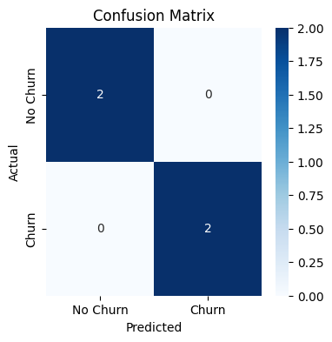
- The accuracy value is 100% which is due to the small test data and the model correctly predicted all test samples without any mistakes.
- Hence the model predicts the ‘Churn’ perfectly based on the data provided. If the model predicts 1-YES for new customers, then there is a high possibility that the customer will churn and is likely to stay if the prediction is 0 - NO.

3. Use Time Series Forecasting (ARIMA/Prophet) to predict future monthly sales.

Since the dataset doesn’t have any date/ month column,let's assume ‘Total_Spend’ represents monthly sales, and we'll create a duplicate monthly time index.
from statsmodels.tsa.stattools import adfuller
from statsmodels.tsa.arima.model import ARIMA
date_range = pd.date_range(start="2022-01-01", periods=16, freq="M") # Monthly data
sales_data = { 'Date': date_range,
'Total_Spend': [5000, 3000, 4500, 2500, 7000, 3200, 5300, 2900,
6000, 3100, 4700, 2600, 5500, 3300, 4900, 2700]}
df = pd.DataFrame(sales_data)
df.set_index('Date', inplace=True)
plt.figure(figsize=(10,5))
plt.plot(df, marker='o', linestyle='-')
plt.xlabel("Date")
plt.ylabel("Total Sales")
plt.title("Monthly Sales Trend")
plt.grid()
plt.show()

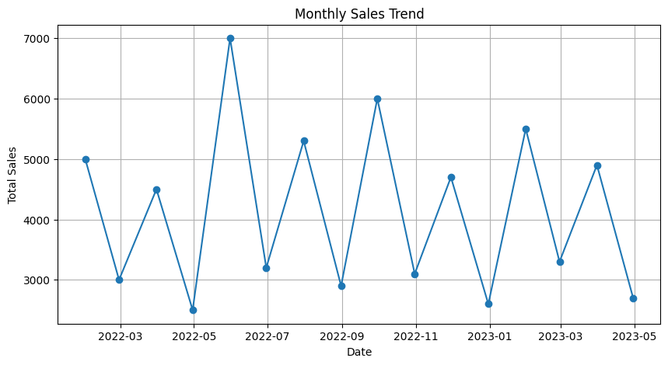
The dataset is not stationary, as the sales have trends that depend on the seasonality. Hence we need to apply differencing, by computing the differences between consecutive observations.

df_diff = df.diff().dropna()
check_stationarity(df_diff['Total_Spend'])plt.figure(figsize=(10, 5))
plt.plot(df_diff, marker='o', linestyle='-')
for date, value in zip(df_diff.index, df_diff['Total_Spend']):
plt.text(date, value, f'{value:.0f}', ha='center', va='bottom', fontsize=8, color='blue')
plt.xlabel("Date")
plt.ylabel("Differenced Sales")
plt.title("Differenced Sales Data (Stationary)")
plt.grid()
plt.show()

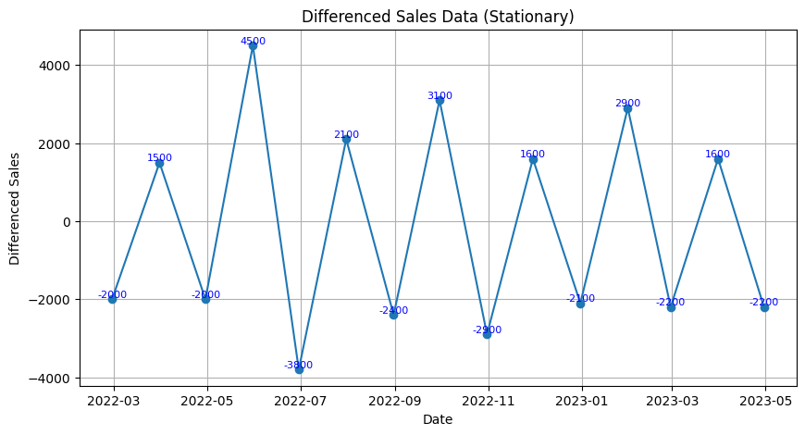

# Fit ARIMA model
model = ARIMA(df['Total_Spend'], order=(1, 1, 1))
model_fit = model.fit()
# Forecast for next 6 months
future_steps = 6
forecast = model_fit.forecast(steps=future_steps)
future_dates = pd.date_range(start=df.index[-1], periods=future_steps + 1, freq='M')[1:]
forecast_df = pd.DataFrame({'Date': future_dates, 'Predicted_Sales': forecast})
forecast_df.set_index('Date', inplace=True)
print(forecast_df)
plt.figure(figsize=(10, 5))
plt.plot(df, label="Actual Sales", marker='o')
plt.plot(forecast_df, label="Forecasted Sales", marker='o', linestyle='dashed', color='red')
for date, value in zip(df.index, df['Total_Spend']):
plt.text(date, value, f'{value:.0f}', ha='center', va='bottom', fontsize=10, color='blue')
for date, value in zip(forecast_df.index, forecast_df['Predicted_Sales']):
plt.text(date, value, f'{value:.0f}', ha='center', va='bottom', fontsize=10, color='red')
plt.xlabel("Date")
plt.ylabel("Total Sales")
plt.title("Sales Forecast (Next 6 Months)")
plt.legend()
plt.grid()
plt.show()
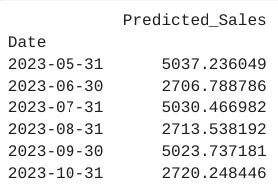
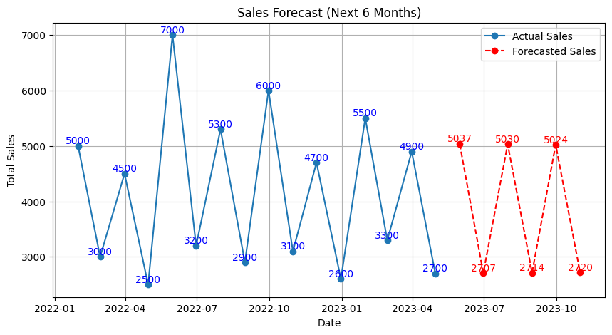

STATISTICAL ANALYSIS FOR BUSINESS INSIGHTS

- ANOVA: To compare sales performance across different regions.

from scipy.stats import f_oneway
# Group sales by region
north = df[df['Region'] == 'North']['Total_Spend']
south = df[df['Region'] == 'South']['Total_Spend']
east = df[df['Region'] == 'East']['Total_Spend']
west = df[df['Region'] == 'West']['Total_Spend']
f_stat, p_value = f_oneway(north, south, east, west)
print(f"F-Statistic: {f_stat:.2f}")
print(f"P-Value: {p_value:.4f}")
if p_value < 0.05:
print("There is significant sales difference across each region!")
else:
print("There is No significant difference in sales across regions!")
plt.figure(figsize=(12, 7))
sns.boxplot(x='Region', y='Total_Spend', data=df, palette='Set2')
plt.title('Sales Distribution by Region')
plt.xlabel('Region')
plt.ylabel('Total Spend')
plt.grid(True)
plt.show()

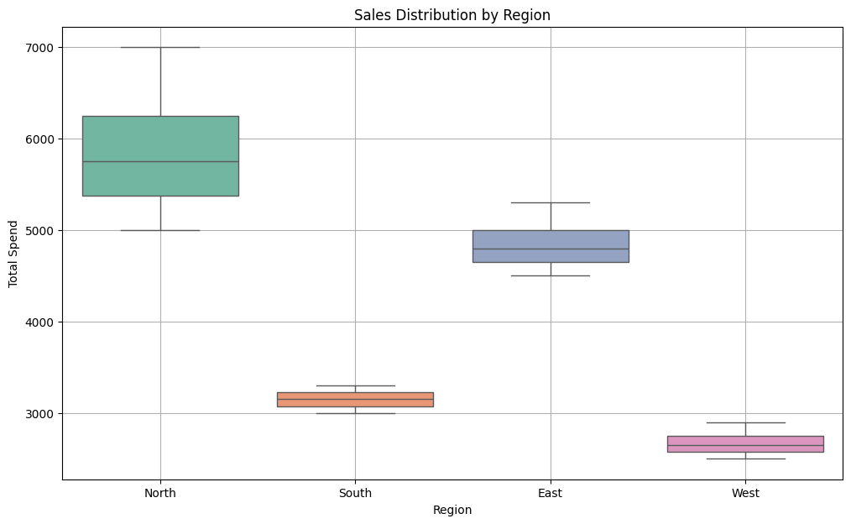
It is evident from the above box plot that the sales difference between regions significantly differs from each other.

- Hypothesis Testing: To validate the impact of promotions on sales growth.

Calculating the linear correlation between ‘Marketing_Spend’ and ‘Total_Spend’.

from scipy.stats import pearsonr
correlation, p_value = pearsonr(df['Marketing_Spend'], df['Total_Spend'])
print(f"Correlation: {correlation:.4f}")
print(f"P-Value: {p_value:.4f}")if p_value < 0.05:
print("There is a significant correlation between Marketing Spend and Total Spend.")
else:
print("There is no significant correlation between Marketing Spend and Total Spend.")

- Factor Analysis: To identify key drivers influencing customer purchase decisions.

import pandas as pd
from sklearn.preprocessing import StandardScaler
from sklearn.decomposition import FactorAnalysis
features = ['Marketing_Spend', 'Seasonality_Index', 'Purchase_Frequency', 'Total_Spend']
X = df[features]
scaler = StandardScaler()
X_scaled = scaler.fit_transform(X)
factor_analysis = FactorAnalysis(n_components=2, random_state=42)
factors = factor_analysis.fit_transform(X_scaled)
factor_loadings = pd.DataFrame(factor_analysis.components_, columns=features)
print("Factor Loadings:\n", factor_loadings)

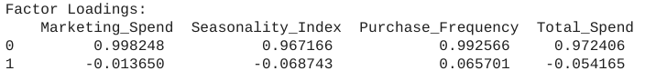

plt.plot(features, factor_loadings.iloc[0], label='Factor 1', marker='o', linestyle='-', color='b')
plt.plot(features, factor_loadings.iloc[1], label='Factor 2', marker='o', linestyle='-', color='r')
plt.title('Factor Loadings for Variables')
plt.xlabel('Variables')
plt.ylabel('Factor Loadings')
plt.grid(True)
plt.legend()
plt.show()

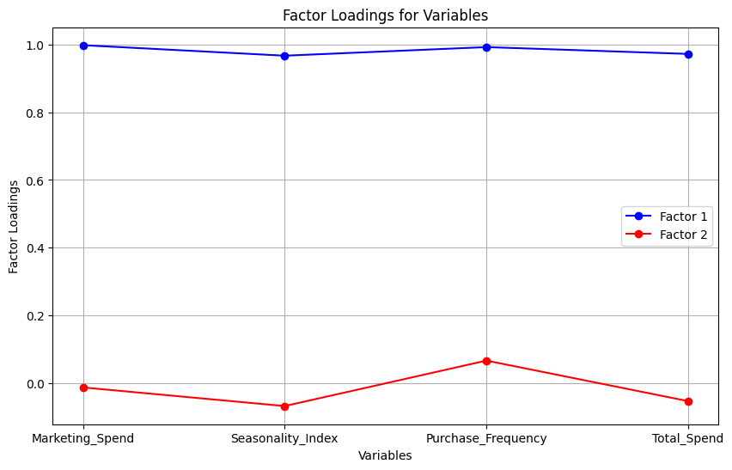
- Factor 1 is the primary driver influencing Total Spend (sales), as it has the highest positive correlation with key variables like Marketing Spend, Seasonality Index, and Purchase Frequency. This indicates that changes in marketing efforts, seasonal trends, and customer purchase frequency directly affect the sales outcome.
- Factor 2, based on its weak loadings, does not provide much insight into sales performance.
- Marketing Spend, Seasonality, and Purchase Frequency are the key drivers of sales (Total Spend) based on Factor 1, and should be closely monitored for improving or optimizing sales strategies.

MACHINE LEARNING FOR CUSTOMER SEGMENTATION

- Use Decision Trees to segment customers based on purchasing behavior.

from sklearn.tree import DecisionTreeClassifier
from sklearn.model_selection import train_test_split
from sklearn.preprocessing import StandardScaler
from sklearn import tree
df['Churned'] = df['Churned'].map({'Yes': 1, 'No': 0})
X = df[['Marketing_Spend', 'Seasonality_Index', 'Purchase_Frequency']]
y = df['Churned']
scaler = StandardScaler()
X_scaled = scaler.fit_transform(X)
X_train, X_test, y_train, y_test = train_test_split(X_scaled, y, test_size=0.2, random_state=42)
model = DecisionTreeClassifier(random_state=42)
model.fit(X_train, y_train)
y_pred = model.predict(X_test)
plt.figure(figsize=(12, 8))
tree.plot_tree(model, feature_names=['Marketing_Spend', 'Seasonality_Index', 'Purchase_Frequency'],
class_names=['No Churn', 'Churn'], filled=True, rounded=True, fontsize=10)
plt.title('Decision Tree for Customer Segmentation Based on Purchasing Behavior')
plt.show()

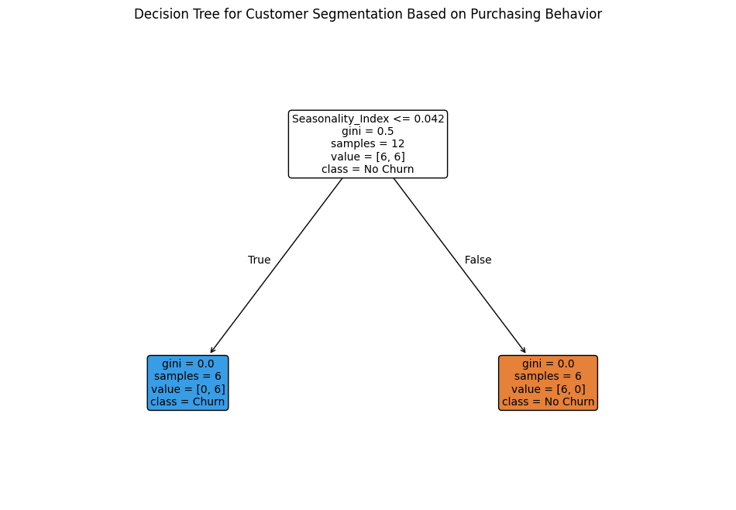
The decision tree is based on the seasonality index;.

- Implement K-Means Clustering to group customers into different spending categories.
from sklearn.cluster import KMeans
from sklearn.preprocessing import StandardScaler
import matplotlib.pyplot as plt
X = df[['Total_Spend', 'Marketing_Spend', 'Purchase_Frequency', 'Seasonality_Index']]
scaler = StandardScaler()
X_scaled = scaler.fit_transform(X)
inertia = []
K_range = range(1, 11) # Trying different K values
for k in K_range:
kmeans = KMeans(n_clusters=k, random_state=42)
kmeans.fit(X_scaled)
inertia.append(kmeans.inertia_)
plt.figure(figsize=(8, 6))
plt.plot(K_range, inertia, marker='o')
plt.title('Elbow Method for Optimal K')
plt.xlabel('Number of Clusters')
plt.ylabel('Inertia')
plt.grid(True)
plt.show()
kmeans = KMeans(n_clusters=3, random_state=42)
df['Cluster'] = kmeans.fit_predict(X_scaled)
plt.figure(figsize=(8, 6))
sns.scatterplot(data=df, x='Total_Spend', y='Marketing_Spend', hue='Cluster', palette='Set2', s=100, edgecolor='black')
plt.title('Customer Segmentation Based on Spending Behavior')
plt.xlabel('Total Spend')
plt.ylabel('Marketing Spend')
plt.grid(True)
plt.show()
cluster_centers = scaler.inverse_transform(kmeans.cluster_centers_)
print("Cluster Centers (in original scale):")
print(pd.DataFrame(cluster_centers, columns=['Total_Spend', 'Marketing_Spend', 'Purchase_Frequency', 'Seasonality_Index']))

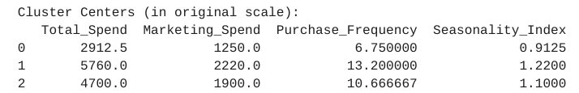
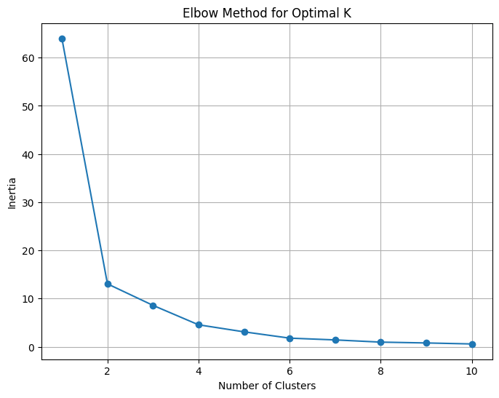
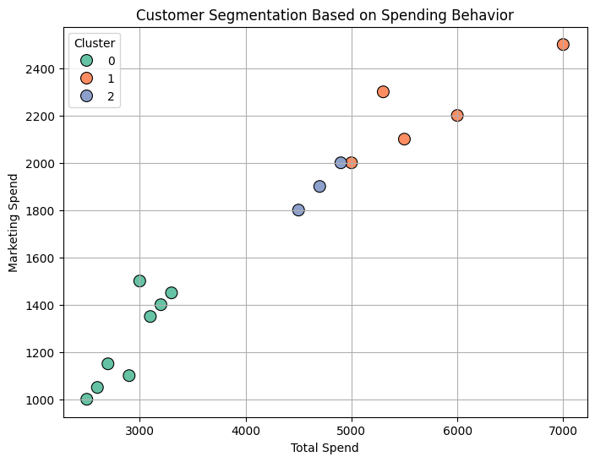
- Cluster 0: Low engaging customers with fewer purchase
- Cluster 1: High value customers who have high purchases
- Cluster 2: Moderate value customers

Business Insights:

- A Linear Regression model was applied to predict Total Sales based on Marketing Spend and Seasonality Index. The model's predictions indicated an overall increase in sales compared to the current performance, with higher predicted sales values driven by increased marketing spend and seasonality.
- Using the ARIMA model, we analyzed historical sales data to forecast future monthly sales. The predicted values indicated a continuing trend of peaks and dips in sales, with high sales values of around £5000 and low sales values around £2000. The forecast mirrors the observed historical pattern, suggesting that fluctuations will likely persist in the coming months.
- ANOVA analysis was conducted to compare sales performance across different regions, revealing significant differences in Total Spend among regions.
- By grouping customers based on their spending patterns, we identified three distinct segments: high-value, moderate-value, and low-value customers. Notably, Marketing Spend was found to have a significant relationship with Total Spend, and it played a crucial role in differentiating customer segments.
- A Decision Tree model revealed that the Seasonality Index is a significant determinant of customer churn. Specifically, customers with a Seasonality Index less than or equal to 0.042 are more likely to churn. This highlights the importance of targeting customers who exhibit low seasonal engagement and creating strategies to retain them.
- Through Factor Analysis, we identified Marketing Spend, Seasonality Index, and Purchase Frequency as the primary drivers influencing Total Spend. The linear correlation between these factors underscores their combined importance in determining customer purchasing behavior and total sales.

Business Recommendations:

- Focused marketing efforts on high-value customers, through personalized campaigns, loyalty programs, and offers could help in maintaining their loyalty and increasing their Lifetime Value (LTV). These customers are most likely to respond positively to additional marketing efforts.
- Focusing on strategies to increase engagement with customers, particularly during off-peak seasons. This could work in higher values for customers with low Seasonality index and in turn likely to reduce or mitigate the churn.
- Since Marketing Spend is strongly correlated with Total Spend, businesses should consider increasing their marketing investments.
- Based on the ANOVA results, which indicate significant differences in Total Spend across regions, tailor sales and marketing strategies to meet the specific needs and preferences of each region.Performing deeper regional analysis to identify unique customer behavior and develop region-specific campaigns and promotional activities will help equalize the regional sales.

